# An upper bound for the Standard Deviation of a Strong Earth Gravity Prior

# Abstract

Ugh.

# Introduction

There is ample evidence that humans represent earth gravity and use it for a variety of tasks such as interception (Ceccarelli et al., 2018; La Scaleia, Zago, Moscatelli, Lacquaniti, & Viviani, 2014; McIntyre, Zago, & Berthoz, 2001; Senot et al., 2012; Zago, McIntyre, Senot, & Lacquaniti, 2008), time estimation (Moscatelli & Lacquaniti, 2011), the perception of biological motion (Maffei et al., 2015) and many more. Recently, we have shown that gravity-based prediction for motion during an occlusion did not only match performance under a 1g expectation, but also quantitatively (Jörges & López-Moliner, 2019). This was an important finding to support our interpretation of the above results as a strong prior in a Bayesian framework of perception (Jörges & López-Moliner, 2017). The results presented in (Jörges & López-Moliner, 2019) indicate that the mean of this strong gravity prior is roughly at 1g (9.81 m/s²), but to fully characterize it, we also need to indicate its standard deviation.

We envision (visual) perception as a two-step process: Encoding and Decoding. During Encoding, low level signals such as luminosity, retinal velocities or orientation are picked up by the perceptual system. However, the same retinal velocities can correspond to vastly different physical velocities, depending on the distance between observer and object. Decoding, then, is the process of interpreting optic flow information. In Decoding, humans often combine sensory input with previous knowledge to obtain a more accurate and precise estimate of the observed state of the world. In some, if not many instances, this combination occurs according to Bayes’ formula, which combines sensory input (Likelihood) and prior knowledge (Prior) according to their respective precisions to yield a more precise and more accurate final percept (Posterior). Now, usually the likelihood might be weighted a bit more heavily; for example when we know that our opponent in tennis *usually* serves in the right corner of the court, but *not always*. We thus take sensory input (e. g. about his body posture while serving) into account only to some extent (see “Normal Prior” scenario in Figure 1). However, in the case of gravity it seems that the expectation of Earth Gravity overrules all sensory information that humans collect on the law of motion of an observed object. On a theoretical level, this is a sensible assumption, since all of human evolution and each human’s individual development occurred under Earth Gravity. In Bayesian terms, the Prior is extremely precise and thus overrules all sensory information represented as the Likelihood.

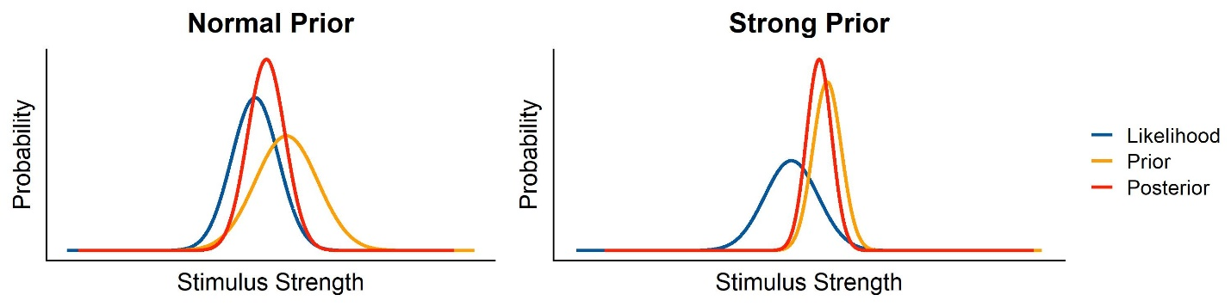

Figure 1: Graphical illustration of Likelihood, Prior and Posterior in a Bayesian framework, for both a normal, relatively shallow Prior, and a strong, extremely precise Prior.

According to our interpretation, we would expect an extremely low value.

In the following, we use the data from our previous study (Jörges & López-Moliner, 2019) to simulate the variability of responses under different assumptions about the standard deviation of the gravity prior.

# Methods

## Participants

A total of eleven (n = 10) participants performed the task, among which one of the authors (BJ). All had normal or corrected-to-normal vision. The remaining participants were in an age range of 23 and 34 years and five (n = 5) were female. We did not test their explicit knowledge of physics, as previous studies suggest that explicit knowledge about gravity has no effect on performance in related tasks(Flavell, 2014; Kozhevnikov & Hegarty, 2001). All participants gave their informed consent. The research in this study is part of an ongoing research program that has been approved by the local ethics committee of the University of Barcelona. The experiment was conducted in accordance with the Code of Ethics of the World Medical Association (Declaration of Helsinki).

## Stimuli

We presented participants with targets of tennis ball size (radius = 0.033 m), shape and texture that moved on parabolic trajectories. The trajectories were determined by the gravity levels (0.7,0.85,1,1.15,1.3g,-1g), the initial vertical velocities (4.5 and 6 m/s) and the initial horizontal velocities (3 and 4 m/s). The different kinetic profiles, as well as the occlusion condition (Short Occlusion: last 20-25%; Long Occlusion: last 45-50% of the trajectory), were presented in random order, but the method guaranteed that each combination was presented the same amount of times. The parabolas were presented in the fronto-parallel plane with no change in depth. Air resistance was simulated to provide a more realistic stimulus. The following equations (<http://www.demonstrations.wolfram.com/ProjectileWithAirDrag/>) determine the x position of the target in time *x(t)*, and the y position of the target in time *y(t)*, respectively, including air resistance:

|  |  |
| --- | --- |
|  | [1] |
|  | [2] |

With being the initial horizontal velocity, the initial vertical velocity, *m* the mass of the target (0.057 kg), *g* the respective gravity value and *c* being the drag coefficient, where we chose 0.005.

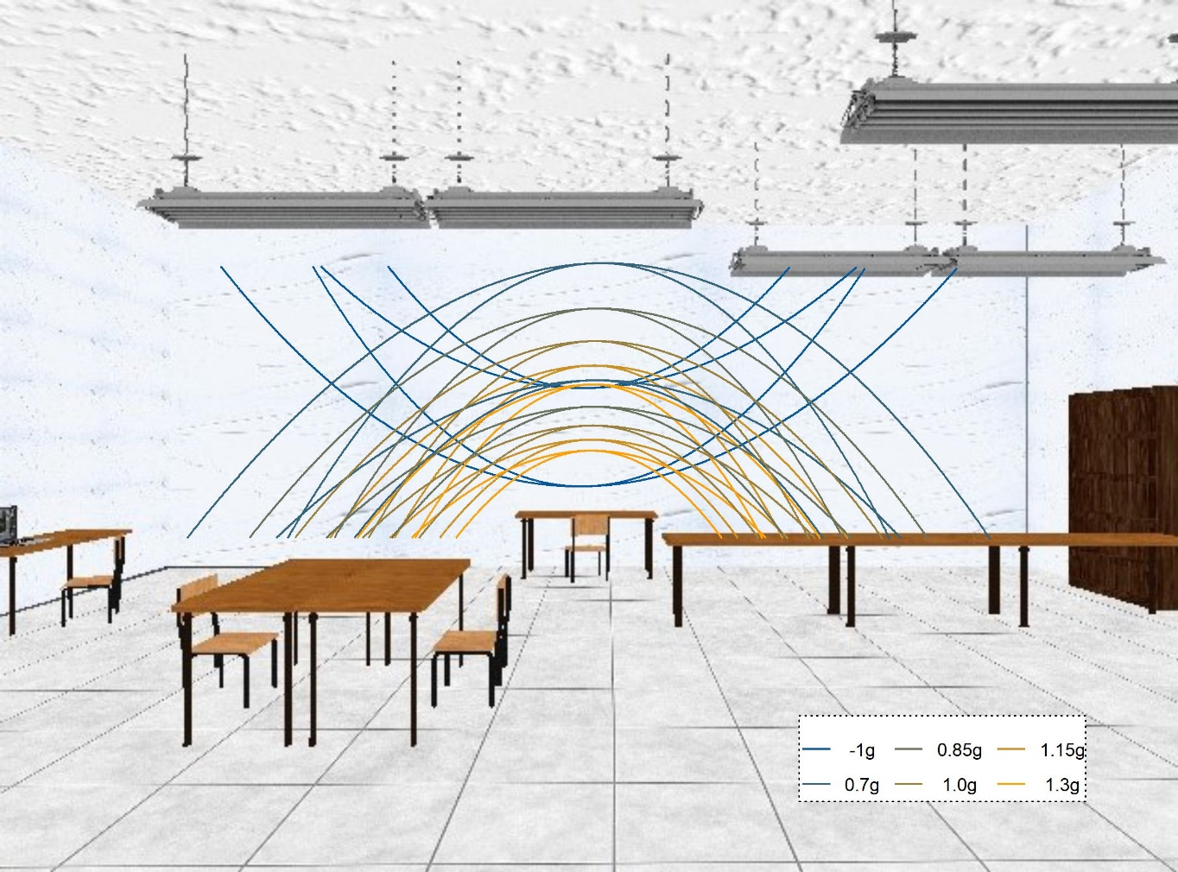

Figure 2: 2D depiction of the visual scene used as environment for stimulus presentation. The stimulus was always presented in front of the white wall and never crossed other areas (such as the lamps of tables) that could introduce low level differences in contrast etc. The lines denote the different parabolic trajectories that along which the targets travelled.

For description of the parabolas, we use a coordinate system where the observer’s position is defined as x = y = z = 0; the x axis runs from left to right, the y axis from down to up and the z axis away from the observer in depth. The starting y position was half a meter above the ground (y = 0.5 m) for positive gravity values (0.7-1.3g) and 3.5 m for negative gravity values (-1g), while the starting x position was moved to the left from the middle of the scene by half of the overall length of the trajectory (x = -length/2 m). The target travels to the right, such that the peak of the parabola was always reached at x = 0 m (or the lowest point for the inverted parabolas). The ball's z position remained constant at z = -6.15 m. The target disappeared at a random point between 20% and 25% (Short Occlusion) or 45% and 50% (Long Occlusion) of the time it would take for it to return to the initial height (y = 0.5 m or y = 3.5 m, respectively). The y end position was marked with an elongated table that was displayed in the target area of the room for targets with positive gravities; it was marked with an elongated lamp hanging from the ceiling for inverted stimuli. We presented the trajectories in a rich environment that provided 3D cues about the object's position in depth (see Figure 1) and used a known object (a tennis ball) as target to recruit prior knowledge consistent with the geometry on display. This has been shown to help activate the internal model of gravity (Lacquaniti et al., 2013; Monache, Lacquaniti, & Bosco, 2019; Zago, La Scaleia, Miller, & Lacquaniti, 2011), that we have previously suggested to be an earth gravity prior(Jörges & López-Moliner, 2017). This environment was constructed such that no low-level cues such as differences in brightness and contrast with the target differed significantly between the different trajectories.

## Apparatus

Two Sony laser projectors (VPL-FHZ57) were used to provide overlaid images on a back-projection screen (244 cm height and 184 cm width) with a resolution of 1920x1080 pixels. The frequency of refresh of the image was 85 Hz for each eye. Circular polarizing filters were used to provide stereoscopic images. Participants stood at 2 m distance centrally in front of the screen and used polarized glasses to achieve stereoscopic vision of the visual scene and the target. The shown disparity was adapted to each participant's inter-ocular distance. The stimuli were programmed in PsychoPy(Peirce, 2007); we added the code to our pre-registration (<https://osf.io/8vg95/>). The projectors introduced a delay of 0.049259 s (SD = 0.001894 s) that will be accounted for in the analysis of timing responses. Data was acquired for a different hypothesis, for which we also tracked participants eye-movements.

Procedure

Participants were first instructed to pursue the target closely with their eyes and to indicate via mouse button click when they believed the target had returned to the starting level (y = 0.5 m/y = 3.5 m). We familiarized subjects with 48 training trials (each combination of experimental variables once), in which the ball reappeared upon mouse click, thus indicating the spatial error. Then, we presented the stimuli in four blocks: 3 blocks of 320 trials each (5 gravities from 0.7g to 1.3g; 2 initial vertical velocities; 2 initial horizontal velocities; 2 occlusion conditions; 8 repetitions per combination). For our eye-tracking hypothesis, we furthermore tested one block of -1g/1g motion, which will not be used in the simulations presented in this paper. After each block, participants could take a break. Five subjects (s1, s3, s5, s7, s9) received the 1g/-1g block as first block, while the other five subjects (s2, s4, s6, s8, s10) received it as last block.

# Results

While we have reported the main results of this experiment in a previous paper (Jörges & López-Moliner, 2019), it is worth reiterating the results for the timing task for the conditions we are using in our simulations. We will report mean timing errors as well their standard deviations for the 0.7-1.3g trials in the Long Occlusion condition.

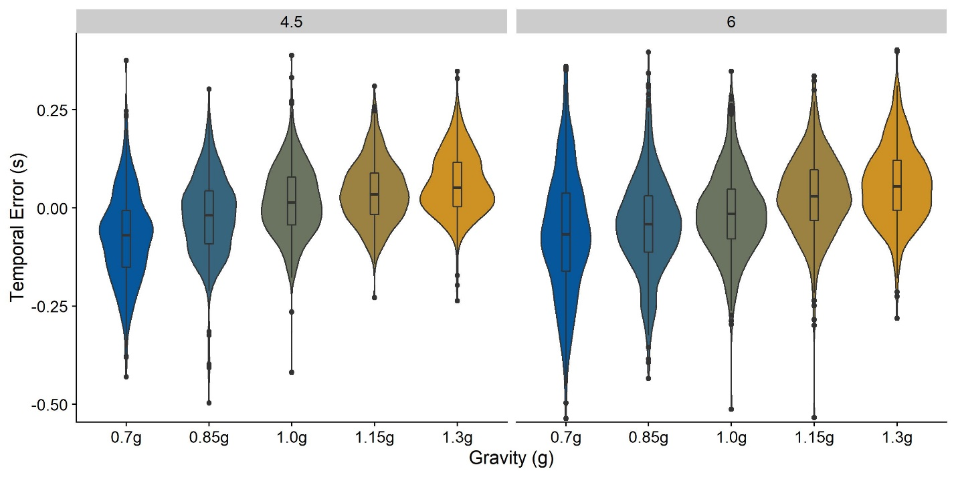

To assess biases, we fitted a Linear Mixed Model where the Temporal Error is explained by­ Gravity as fixed effect, and intercepts per Subject as random effects. We compare this Test Model to a Null Model, without fixed effects and only intercepts per Subject as random effects. An ANOVA showed that the Test Model is significantly better than the Null Model (p < 0.001), and the regression coefficient for Gravity is 0.022 (SE = 0.0007). That is, higher gravities are related to higher absolute values of the temporal errors; higher gravities thus lead to too late responses, while lower gravities lead to too early responses. Figure 1 shows the Temporal Errors

To assess precision, we calculated the absolute Temporal Error for each trial with regards to the median of each condition. We then fitted a Linear Mixed Model where this Precision proxy is predicted by gravity as fixed effect, and intercepts per Subject as random effects. We compare this Test Model to a Null Model, without fixed effects and only intercepts per Subject as random effects. An ANOVA showed that the Test Model was significantly better than the Null Model (p < 0.001), and the regression coefficient for the fixed effect Gravity is -0.003 (SE = 0.0004). This indicates that higher gravities are related to lower variability, most likely due to the fact that the interval for which the motion has to be extrapolated is shorter. Interestingly, when comparing -1g and 1g, we find that included conditions. Table 1 lists all mean temporal errors and the respective standard errors across participants.

|  |  |  |  |  |  |  |  |  |
| --- | --- | --- | --- | --- | --- | --- | --- | --- |
|  |  | **0.7g-1.3 Block** | | | | | **-1g/1g Block** | |
|  |  | *0.7g* | *0.85g* | *1g* | *1.15g* | *1.3g* | *-1g* | *1g* |
| **4.5 m/s** | *Mean* | -0.07 | -0.02 | 0.02 | 0.04 | 0.06 | 0.09 | 0.04 |
| *SD* | 0.11 | 0.10 | 0.09 | 0.08 | 0.08 | 0.11 | 0.09 |
| **6 m/s** | *Mean* | -0.06 | -0.04 | -0.01 | 0.03 | 0.06 | 0.06 | 0.03 |
| *SD* | 0.16 | 0.12 | 0.10 | 0.10 | 0.10 | 0.14 | 0.11 |

Interestingly, precision seems to be higher for 1g trials than for -1g trials. To test this, we fitted a Linear Mixed Model to the -1g/1g data, where gravity as fixed effect factor and subjects as random effects predict the absolute Temporal Error as proxy for the precision. We compare this Test Model with a Null Model where only subjects as random effects predict the absolute Temporal Error. An ANOVA showed that the Test Model was significantly better than the Null Model (p < 0.001), and the regression coefficient for the fixed effect factor Gravity is -0.01 (SE = 0.003), indicating that the absolute error is lower and thus the precision is higher for 1g than for -1g. On a theoretical level, this is in line with previous findings (Indovina et al., 2005) showing that the internal representation of gravity is not activated when upwards motion is presented, even when the absolute value of acceleration impacting the object is equal to the absolute value of earth gravity (9.81 m/²). The precision may thus be higher for 1g than for -1g because the internal model of gravity is utilized for 1g, but not for -1g trials.

# Modelling

Procedure

As the temporal difference between air drag present and air drag absent are miniscule for our trajectories, we decided to neglect air drag for these simulations and use the equation for linearly accelerated motion as an approximation.

|  |  |
| --- | --- |
|  | [3] |
|  | [4] |

As evidenced by a comparison between equations (1) and (2) and equations (3) and (4), the computational complexity increases significantly if we want to accommodate air drag, without relevant gains in accuracy.

There are two different ways to approach this problem. First, we can model the temporal responses of our subjects assuming different standard deviations for the gravity prior and minimize the difference between the standard deviations of the responses we observed in our subjects and the model standard deviations. In this case, we would draw the values for , and from distributions with given means and standard deviations, and compute a simulated temporal response from these values. The mean for would be the last observed velocity in y direction and the standard deviation can be computed based on Weber fractions for velocity discrimination from the literature. The mean for is the distance in y direction between the point of disappearance and the reference height. The mean for is 9.81 m/s², and we optimize over its standard deviation to match the standard deviation observed in the subjects’ temporal responses.

A second approach would be to solve equation (3) for , and then compute its mean and standard deviation analytically based on the means and standard deviations of , and .

|  |  |
| --- | --- |
|  | [5] |

However, as evident from Equation 5, this would entail computing the standard deviation of the quotient of two distributions. This is not possible to our knowledge, for which reason we will focus on modelling responses.

### Assumptions

Before presenting the results, we outline our assumptions and provide the underlying rationale.

**Use of Equation (3)** – In our previous paper, we have shown that predictions based on Equation 3 fit observed temporal errors reasonably well (Jörges & López-Moliner, 2019). This is particularly the case when subjects extrapolated motion for larger time frames in the Long Occlusion condition. The difference in predictions for this equation with regards to Equation (2) is 3 ms, and the added computational complexity does not justify the potentially added accuracy.

 – The velocity term in Equation (3) () refers to the part of the full distance the target moved because of its initial velocity. Our targets disappeared right after peak, therefore their initial velocity was very low. The velocity term thus contributes less to the full estimate than the gravity term. The last observed velocity in y direction serves as mean for the distribution from which we draw the velocity for each trial. Weber fractions for velocity discrimination reported in the literature are about 5 % for motion presented in the fovea. This is relevant as lower thresholds have been reported for motion presented in the peripheral vision. However, our participants had the added difficulty of having to extract the vertical velocity component from parabolic motion. We estimate that this might double the difficulty, which would correspond to a Weber fraction of 10 %. Weber fractions are that difference in stimulus intensity where subjects display a 75 % chance of discrimination. To calculate the standard deviation of the distribution of perceived velocities from the Weber fraction, we have to find that normal distribution where a difference of 10 % from its mode leads to a proportion of responses of 25/75 %. For a standardized normal distribution with a mean of 1, this is a standard deviation of 0.148. Note that, by using a standardized normal distribution, we assume that Weber fractions are constant across the relevant range of stimulus strengths.

– Again, as the target disappeared right after peak, this terms importance is secondary with regards to the gravity term. In very easy conditions, Weber fractions of 3 % to 5 % are observed for distance estimate in the front parallel plane (Norman, Todd, Perotti, & Tittle, 1996). According to the procedure outlined above, we find a standardized standard deviation of 0.074 for the distribution of this value.

**t** –  The response time t is measured directly in our task, both in mean and variability.

### Remaining Variability

For our simulations, we rely on accounting for every source of variability in the responses. In our understanding, there are two further sources of error beyond perceiving and representing **g**, and : the motor response and the integrative mechanism that combines different pieces of information. Such errors are likely to vary strongly between tasks, for which reason variability reported in the literature is of limited use. To estimate the error introduced by these further factors, we thus take advantage of previous results indicating that the gravity model is not activated for upside-down motion (Indovina et al., 2005), a hypothesis which is also supported by our data.

Under this assumption, we can use the responses for the inverted gravity condition to get an estimate of the errors introduced by these sources of variability. An inactivation of the gravity prior would mean that t­he gravity acting upon the object should be represented with the same precision that arbitrary accelerations are represented. We previously found Weber fractions of between 13 % and beyond 30% for arbitrary gravities (Jörges, Hagenfeld, & López-Moliner, 2018), which is in line with those found for linear accelerations (Werkhoven, Snippe, & Alexander, 1992). We thus proceed with a value of 20 %, which corresponds to a normalized standard deviation of 0.295 (see procedure above). We use these values for **g**, and ­­ to stimulate data sets for the -1g trials. Using the optim() function implemented in R, we optimize over different standard deviations representing the remaining error, to minimize the quadratic error between the standard deviations of the simulated timing error and the observed timing error. We found the best fit for a normalized standard deviation of 0.125.

### The Standard Deviation of the Gravity Prior

We then proceed to apply these values to simulate data sets based on the above assumptions, get the standard deviations for the timing error and compare them to standard deviations of the observed timing errors. We restrict this comparison to the 0.7g/0.85g/1g/1.15/1.3g condition, as we expect the gravity model not to be activated for inverted gravitational motion. We furthermore only use the Long Occlusion condition, for which we have previously shown that an earth-gravity based predictions fit the data best. For a discussion of factors impacting the performance of the model for short occlusions, see (Jörges et al., 2018). We first simulate a range of sensible standard deviations (from 0.01, corresponding to an extremely precise representation, to 0.5, corresponding to a very imprecise representation with barely any impact on the final percept, in steps of 0.02) to determine the lower and upper bounds of the optimization interval. We find the errors to be lowest around 0.2, and choose thus 0.15 as the lower bound and 0.25 as the upper bound. We then search for that standard deviation that minimizes the error between simulated and observed timing errors, using the optim() function implemented in R (R Core Team, 2017). For each iteration, we simulate 500 data sets and minimize the mean error between simulated and observed timing errors across these 500 data sets. The R code we used for these simulations can be found on Github (<https://github.com/b-jorges/SD-of-Gravity-Prior>), including extensive annotations. We found a normalized standard deviation of 0.2 for the gravity prior, which corresponds to a standard deviation of about 2 m/s² for a mean of 9.81 m/s².

## Discussion

Based on the fact that humans in many tasks and circumstances assume that objects in their environment are affected by earth gravity, it has been suggested that we maintain a representation of this value, which we then recruit to predict the behavior of objects in our environment. We recently interpreted this representation as a Strong Prior in a Bayesian framework (Jörges & López-Moliner, 2017). A “Strong Prior” is a prior with a reliability so high that it overrules any sensory input represented in the likelihood. Based on data from timing task (previously reported in Jörges & López-Moliner, 2019), we make an attempt at determining the standard deviation of a hypothetical Strong Earth Gravity Prior. Our general approach is to account for other sources of perceptuo-motor variability in the task based on thresholds reported in the literature, and attributing the remaining variability to the Gravity Prior. Based on this approach, we find a standard deviation of 2 m/s², for a prior with a mean of 9.81 m/s², which corresponds to a Weber fraction of 13,8 %. This is considerably lower than Weber fractions generally observed for acceleration discrimination, but higher than Weber fractions for speed discrimination.

Interestingly, when we modelled the timing errors with a fixed value of 9.81 m/s² (i. e. in a non-Bayesian framework where the value of earth gravity is not represented as a distribution, but a value set at 1g; Jörges & López-Moliner, 2019), we found that our results fit the observed timing error quite nicely for each gravity value. That is, the observed gravity (corresponding to the Likelihood) had no discernable influence on the final percept (Posterior). However, in a Bayesian framework, this is only possibly if the Likelihood is extremely shallow and/or the Prior is extremely precise. A Weber fraction of about 30 % for the likelihood (which we assume for acceleration discrimination), and a Weber fraction of 13.8 % for the prior (as modelled) would not result in completely discarding the likelihood (see also Figure 1). Our results thus reveal a mismatch between the observed mean, the modelled standard deviation, behavioral results and a Bayesian explanation.

We see two possible ways to explain this mismatch. Firstly, our observed standard deviation for the gravity prior could be an upper bound. Our method relies on identifying all sources of variability and allotting variability in the response accordingly. Since we did not measure our participants’ Weber fractions for velocity and distance discriminations individually, but rather used averages reported in the literature for somewhat different tasks, this may have distorted how much variability estimated distances and velocity at disappearance introduced in the response. Furthermore, when estimating the variability introduced in the motor response, we part from the premise that the internal model of gravity is not activated at all for -1g motion. However, we observe a bias to respond too late in this condition, suggesting that humans expect objects to accelerate less when moving upwards. This could be taken as evidence that the internal model of gravity is still activated to some extent. In this case, we would need to lower the Weber fraction we assumed when determining the motor error. This in turn would give us a higher estimate of motor variability, which in turn would lead to a lower standard deviation for the gravity prior. However, this pattern in our data is also consistent with humans taking arbitrary accelerations into account insufficiently in perceptuo-motor tasks, which has been reported repeatedly (Benguigui, Ripoll, & Broderick, 2003; Bennett & Benguigui, 2013; Brenner et al., 2016; Werkhoven et al., 1992). The value of 2 m/s² we modelled above may nonetheless be an upper bound for the standard deviation of the Earth Gravity Prior.

A second possibility is that prior knowledge and online perceptual input are combined in a non-Bayesian fashion (and we should thus avoid the terminology “Prior”, “Likelihood” and “Posterior”), where the mean of the final percept is set according to an acceleration of 9.81 m/s², while its standard deviation is determined by a (not necessarily Bayesian) combination of prior knowledge and online sensory information.

## Conclusion

NEVERMIND. BUH.

Benguigui, N., Ripoll, H., & Broderick, M. P. (2003). Time-to-contact estimation of accelerated stimuli is based on first-order information. *Journal of Experimental Psychology. Human Perception and Performance*, *29*(6), 1083–1101. https://doi.org/10.1037/0096-1523.29.6.1083

Bennett, S. J., & Benguigui, N. (2013). Is Acceleration Used for Ocular Pursuit and Spatial Estimation during Prediction Motion? *PLoS ONE*, *8*(5). https://doi.org/10.1371/journal.pone.0063382

Brenner, E., Rodriguez, I. A., Muñoz, V. E., Schootemeijer, S., Mahieu, Y., Veerkamp, K., … Smeets, J. B. J. (2016). How can people be so good at intercepting accelerating objects if they are so poor at visually judging acceleration? *I-Perception*, *7*(1), 1–13. https://doi.org/10.1177/2041669515624317

Ceccarelli, F., La Scaleia, B., Russo, M., Cesqui, B., Gravano, S., Mezzetti, M., … Zago, M. (2018). Rolling motion along an incline: Visual sensitivity to the relation between acceleration and slope. *Frontiers in Neuroscience*, *12*(JUN), 1–22. https://doi.org/10.3389/fnins.2018.00406

Flavell, J. C. (2014). *An investigation into the directional and amplitude aspects of an internal model of gravity*. Manchester Metropolitan University.

Indovina, I., Maffei, V., Bosco, G., Zago, M., Macaluso, E., & Lacquaniti, F. (2005). Representation of visual gravitational motion in the human vestibular cortex. *Science (New York, N.Y.)*, *308*(April), 416–419. https://doi.org/10.1126/science.1107961

Jörges, B., Hagenfeld, L., & López-Moliner, J. (2018). The use of visual cues in gravity judgements on parabolic motion. *Vision Research*, *149*, 47–58. https://doi.org/10.1016/J.VISRES.2018.06.002

Jörges, B., & López-Moliner, J. (2017). Gravity as a Strong Prior: Implications for Perception and Action. *Frontiers in Human Neuroscience*, *11*(203). https://doi.org/10.3389/fnhum.2017.00203

Jörges, B., & López-Moliner, J. (2019). Earth-Gravity Congruent Motion Facilitates Ocular Control for Pursuit of Parabolic Trajectories. *Scientific Reports*, *9*(1), 1–13. https://doi.org/10.1038/s41598-019-50512-6

Kozhevnikov, M., & Hegarty, M. (2001). Impetus beliefs as default heuristics: dissociation between explicit and implicit knowledge about motion. *Psychonomic Bulletin & Review*, *8*(3), 439–453. https://doi.org/10.3758/BF03196179

La Scaleia, B., Zago, M., Moscatelli, A., Lacquaniti, F., & Viviani, P. (2014). Implied dynamics biases the visual perception of velocity. *PLoS ONE*, *9*(3). https://doi.org/10.1371/journal.pone.0093020

Lacquaniti, F., Bosco, G., Indovina, I., La Scaleia, B., Maffei, V., Moscatelli, A., & Zago, M. (2013). Visual gravitational motion and the vestibular system in humans. *Frontiers in Integrative Neuroscience*, *7*(December), 101. https://doi.org/10.3389/fnint.2013.00101

Maffei, V., Indovina, I., Macaluso, E., Ivanenko, Y. P., Orban, G. A., & Lacquaniti, F. (2015). Visual gravity cues in the interpretation of biological movements: Neural correlates in humans. *NeuroImage*, *104*(October 2014), 221–230. https://doi.org/10.1016/j.neuroimage.2014.10.006

McIntyre, J., Zago, M., & Berthoz, A. (2001). Does the Brain Model Newton’s Laws. *Nature Neuroscience*, *12*(17), 109–110. https://doi.org/10.1097/00001756-200112040-00004

Monache, S. D., Lacquaniti, F., & Bosco, G. (2019). Ocular tracking of occluded ballistic trajectories: Effects of visual context and of target law of motion. *Journal of Vision*, *19*(4), 1–21. https://doi.org/10.1167/19.4.13

Moscatelli, A., & Lacquaniti, F. (2011). The weight of time: Gravitational force enhances discrimination of visual motion duration. *Journal of Vision*, *11*(4), 1–17. https://doi.org/10.1167/11.4.1

Norman, J. F., Todd, J. T., Perotti, V. J., & Tittle, J. S. (1996). The Visual Perception of Three-Dimensional Length. *Journal of Experimental Psychology: Human Perception and Performance*, *22*(1), 173–186. https://doi.org/10.1037/0096-1523.22.1.173

Peirce, J. W. (2007). PsychoPy—Psychophysics software in Python. *Journal of Neuroscience Methods*, *162*(1–2), 8–13. https://doi.org/10.1016/J.JNEUMETH.2006.11.017

R Core Team. (2017). *A Language and Environment for Statistical Computing. R Foundation for Statistical Computing,*. Retrieved from http://www.r-project.org/.

Senot, P., Zago, M., Le Seac’h, a., Zaoui, M., Berthoz, a., Lacquaniti, F., & McIntyre, J. (2012). When Up Is Down in 0g: How Gravity Sensing Affects the Timing of Interceptive Actions. *Journal of Neuroscience*, *32*(6), 1969–1973. https://doi.org/10.1523/JNEUROSCI.3886-11.2012

Werkhoven, P., Snippe, H. P., & Alexander, T. (1992). Visual processing of optic acceleration. *Vision Research*, *32*(12), 2313–2329. https://doi.org/10.1016/0042-6989(92)90095-Z

Zago, M., La Scaleia, B., Miller, W. L., & Lacquaniti, F. (2011). Coherence of structural visual cues and pictorial gravity paves the way for interceptive actions. *Journal of Vision*, *11*(10), 1–10. https://doi.org/10.1167/11.10.13.Introduction

Zago, M., McIntyre, J., Senot, P., & Lacquaniti, F. (2008). Internal models and prediction of visual gravitational motion. *Vision Research*, *48*(14), 1532–1538. https://doi.org/10.1016/j.visres.2008.04.005